Jessica Chen

Kristina Ming

**Tunnel Diode GUI User Guide**

Background

The following circuit uses a tunnel diode to produce high speed switching of the output voltage as the input voltage increases from zero.

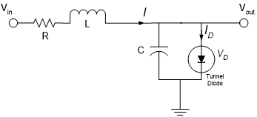

The tunnel diode is given by:



with $I_{D}$ in mA and $V_{D}$ in V.

The circuit has a pulse input voltage of the following form:

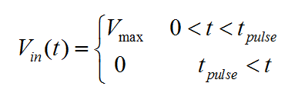

$t_{pulse}$ and $V_{max}$ should be long enough and low enough, respectively, such that the output voltage can reach its maximum before falling back to zero. This is most easily witnessed by the output voltage reaching a plateau (see below).

For combinations of $t_{pulse}$ and $V_{max}$ that reach the maximum output voltage, the rise time should come out to be about 10 ns.

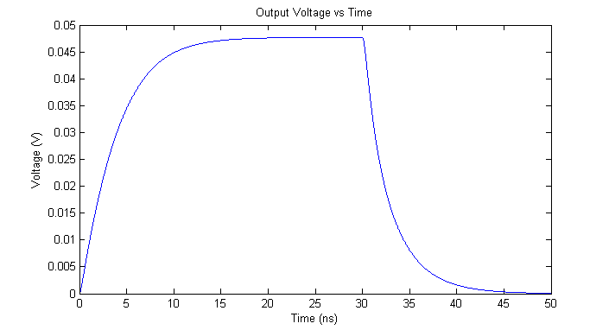

Below is the bifurcation plot for the system. The lower and upper branches are stable and the middle of the “S” is unstable.

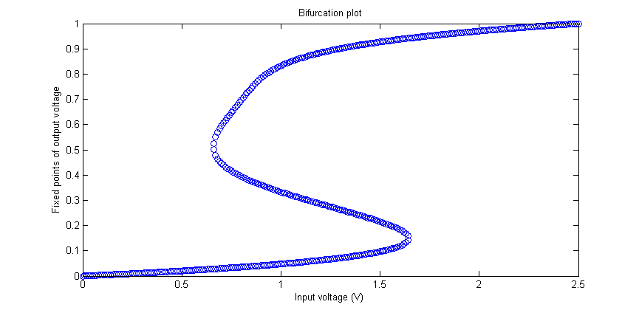

Usage

Upon first starting the GUI, the user can enter $t_{pulse}$ and $V_{max}$ to dictate the input voltage. Only numbers can be entered. To plot the output voltage as a function of time, the “calculate” button should be pressed.

If reset is pressed, $t_{pulse}$ and $V_{max}$ will be reset to its default value of 30 ns and 1 V.